 | EMWIS/SEMIDE Portal Toolkit
 | User manual
 | Manual version | 1.0
 | Date | 31 July 2026
 | Author | Madalina Sauca

Table of contents

1 Introduction 3
1.1 Audience 3
1.2 Terms and abbreviations 3
2 Understanding the interface 4
3 Registration and authentication 5
4 Portal structure and functionality 6
4.1 Content structure 6
4.2 Portal services 6
4.2.1 e-Flash and Push services 7
4.2.2 Welcome page customization 7
4.2.3 SEMIDE Forum 7
4.2.4 Site map 7
4.3 Search 8
4.3.1 Free text search 8
4.3.2 Advanced search 9
4.3.3 Search across multiple portals 10
4.3.4 Custom search mechanisms 10
5 Multilinguality approach 10
5.1 Multilingual interface 10
5.2 Multilingual content 11

Introduction
This manual describes the end user functionalities of the SEMIDE (version 2) website portal that is based on the product Naaya architecture. The Naaya portal toolkit is a multilingual web content management system that allows users with all kind of backgrounds to administrate various aspects of a portal, with respect to their privileges and areas of expertise (content contributors, validators or managers, technical or non technical administrators, translators, etc.). It is a framework that works on top of the Zope (http://www.zope.org) open source web application server and development system.

Audience
This manual provides information for the end users of the portal.

Terms and abbreviations
Abbreviation | Meaning
CMS | Content Management System
PM | Portal Manager
GUI | Graphic User's Interface
CM | Content Manager
NFP | National Focal Point
Portlet | Reusable Web components that display relevant information to portal users
Table 1 - List of abbreviations and their meaning

Understanding the interface
The graphic user interface is structured into several well-defined areas and this chapter describes the role and place for each of them.
All portal pages are constructed in a consistent manner, based on the same kind of templates for the header and footer areas, a dynamic left side menu, a set of right portlets and variable page content. This offers a consistent look and feel throughout the entire site and gives visitors a sense of place and easy navigation.
The header area is composed of:
- Authentication area - information and links for the users’ authentication status.
- Top service links list – contains links to specific portal services (detailed in section 4.2)
- Logo area and site titles
- On the top main navigation there can be found
    - the content links list - easy to access links from all pages that lead to area of great relevancy in the portal
    - the language select box - list of all available languages in the portal, which, upon selection, turns the portal interface and content in that language (if the translation is available)
- Quick access links – allow quick access to relevant pages of the portal.
- Breadcrumb trail bar - helps users to determine where they are (in the portal hierarchy) and gives them the possibility to return up at any level between their current position and the site root.
- Search bar – free text search field that leads to a page that allows the refining of the results.
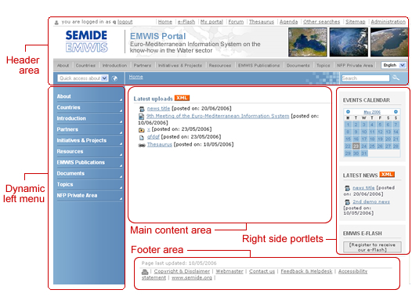
Figure 1 - The generic page elements
The Left side menu displays either the main sections of the portal or the listing of the current main section sub-folders.  There is a strong correspondence between the links list from the top bar and the left side menu. If a main topic is selected in the top bar, the left side column will display its sub-categories on 2 hierarchical levels.  Example:  If a user selects the main topic “Initiatives and Projects” (either from the top navigation bar, or from the initial left menu), the left column will display a sub-menu corresponding to that topic subcategories. Each of the listed items can be expanded as well, as shown in the Figure 2.  In the left menu, the selected items appear highlighted. | 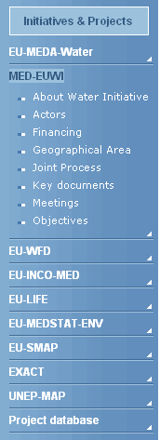  Figure 2 - Left side column

The footer area remains the same in all pages and offer access to various user services.
The portal graphical layout is compliant to the most important web standards:
- the site information is accessible to all users (including users with disabilities), to all types of devices (different browsers, PDAs and mobile phones, TVs, speech synthesizers, Braille interpreters, TVs, printers, etc.) and to search engines
- usability standards
- modern mark-up standards (XHTML, CSS2, etc.)
The portal has different display versions for print (contains only useful content and ignores navigation elements) and for handheld browsers.

Registration and authentication
In order to be able to access certain portal functions, end users must register and log in the system. The identification status of a user browsing the portal is indicated in the upper left corner, either as [you are not logged] or [you are logged in as <username>].
The login page offers support for authenticating for the people that already created an account and also gives a link to the registration page for newcomers. Aside from the account information (username and password), the full name and email address are asked from visitors, in order to allow them to later use the email services offered by the portal and also to give administrators the possibility to control the list of accounts.
Upon creation of a new account, users will receive a confirmation email.
The newly created user will have no role on this portal. In order to obtain further privileges to contribute content, create topics on the forum, etc., one must contact the Webmaster and explain the reasons of such request.
Once logged in, one can either close the browser or log out explicitly using the upper-left link which appears instead of “log in”. Depending on the setting of the operating environment, the logout operation might not succeed so a few tips to overcome that are given on the corresponding page.

Portal structure and functionality

Content structure
The content structure of this portal is outlined by the following main topics:
- “About EMWIS” provides introductory data about EMWIS objectives, structure, funding, etc.
- “Countries” is a section dedicated to provide information regarding EMWIS-related activities in each participant country
- “Partners” group several data about organizations which EMWIS has partnership agreements with
- “Initiatives & Projects” present in brief the main initiatives dealing with water issues in the Euro-Mediterranean area
- The “Resources” folder is a container for news, upcoming events, publications and other useful EMWIS resources
- The “Documentation” contains the standard key reference documents in the water domain
- “Topics” contains various thematic folders which group information throughout the website, indexed with thesaurus keywords from a predefined set of themes
- “Who does what” offers access to the EMWIS thematic directory
- “NFP Private Area” is the container of information restricted to NFP members

Portal services
All these services can be accessed from the top administration set of links: e-Flash, My portal, Forum, Thesaurus, Agenda, Crawler, FAQ, Sitemap.
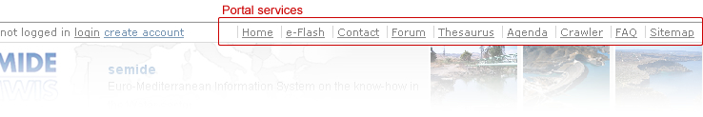
The link to the Administration area is meant for users with higher privileges across the portal. Such functionalities are detailed in the “EMWIS Portal Toolkit – Administrator’s guide”.

e-Flash and Push services
The SEMIDE website sends out a monthly newsletter to all subscribers, called e-Flash. It is a revised compilation of news, events and documents published during the previous month.
In order to subscribe to e-Flash and personalise their profile, users should access the corresponding top link from the navigation bar. If a visitor does not yet have an account in the portal, he/she is given the possibility to create one from here and also to choose the e-Flash and Push services preferences. For the existing users who logged on before accessing this form, only specifying the preferences will be required.
Since the newsletter is sent in all languages available on the portal, subscribers are able to choose the language they prefer for the newsletter and/or decide to be notified each time a piece of content is uploaded in the portal. The notifications will be sent to the email address specified in the account information.
In order to stop receiving instant notifications and/or the monthly newsletter, users have to access this page and un-check the desired options.

Welcome page customization
This service can be accessed from the top administration set of links – “My Portal” option. Any authenticated user can set their own welcome page to which he/she will be automatically redirected upon login.
The selection of the preferred home-page can be easily made using the pick button. A pop-up will display the portal structure and the user will be able to choose his/hers page from the list.
In order to reset this feature and start with the default portal front page, users should just leave this field empty.

SEMIDE Forum
The discussion forum can be accessed from the top administration set of links. It has a standard functionality for such collaborating tool: for each topic the defined by administrators, authenticated users can post new messages, reply to existing ones and thus creating threads.
New topics can be created only by high privileged users so it is advised to contact the webmaster and propose a new one.

Site map
This page presents the hierarchical structure of the portal, containing links to every page of the website
Each topic containing sub-items has an expand/collapse button which gives users the possibility to view the website structure as a tree of links, and to reach certain pages more easily this way.

Search

Free text search
Free text search functionality can be accessed from the upper right corner of each page. The search is performed in the content published on the entire portal (inside titles, descriptive texts, etc. and also in the uploaded files: *.doc, *.pdf, *.xls etc.). By default, the search is carried out in the translations of the content in the selected language.
For instance, if a document contains the word “Roma” in its English version but it is not translated to French and the language selected by the end user at the time of search is French, such document will not be among the results by the query string “Roma”. In the free text search page it is possible to also select more than one languages to search in, meaning that the query string will be sought inside all corresponding translations of the items.
The search expression can be refined by the usage of Boolean operators:
boolean operator | example of use | generated search result
and | fish and water | The two words fish and water must occur somewhere in the document but not necessarily together or in any order.
or | fish or water | Either the word fish or the word water must occur somewhere in the document.
not | not fish and not water | The word fish and not the word water must occur somewhere in the document.
“ “ | "water fish" | The exact expression water fish must occur somewhere in the document.
* | wate* | Everything starting with “wate”
Table 2 - usage of Boolean operators in search strings
The search returns the results batched 10 per page, for each item displaying the following information: type, title (linked to the search result page), language versions for which a translation was provided (also linked to the corresponding pages), and the last updated date.
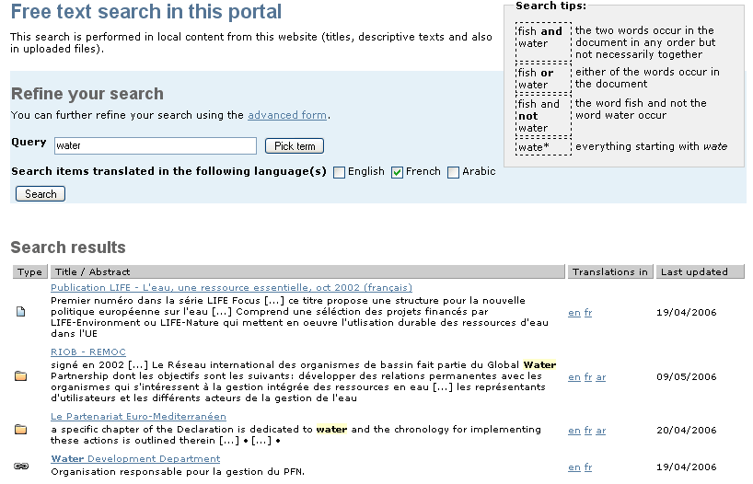
Figure 3 - Free search results

Advanced search
The advanced search gives end users the possibility to define more filters in order to further refine the results by:
- specifying their content type(s) and/or
- restricting to the ones that are translated into certain language(s) and/or
- restricting to the ones that have been released during a certain time period.

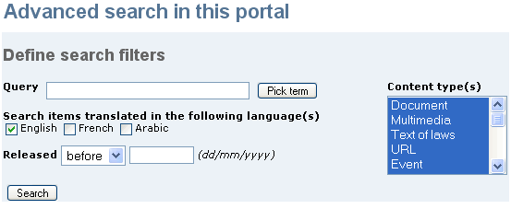
Figure 4 – The advanced search form
The string query field can be filled either manually or by picking terms from the thesaurus. In case of thesaurus terms, each term and its translations in all selected languages will be searched in the content.

Search across multiple portals
The top level link “Crawler” leads to the search across multiple portals form; it allows searching content published around the SEMIDE network (only portals using this portal kit allow this feature).
End users see the list of portals that will be searched and can select the ones they prefer.

Custom search mechanisms
Aside from the search forms described above, customised search pages are available in certain portal folders:
- Project database: the user searches projects using a form that also has filters for organisation and language.
- Agenda: the user searches events using a form with the following supplementary fields: type, geo-zone, status and period.
- News: the user searches news that match the a free text query plus some optional criteria such as news type and news date.

Multilinguality approach
The SEMIDE website is based on a multilingual application, able to provide a user interface and textual content in different languages.
All pages are encoded in UTF-8 (Unicode) which means that all characters and signs from any language are supported.

Multilingual interface
The current language in which the interface is displayed at one moment, is the one selected in the language combo box present on the right side of the navigation bar. This “active” language (previously selected by the user or set as default by the system) is maintained while navigating through the portal until some other language selection is made.
The end user can manually choose the presentation language from the available ones by using the “Select language” combo box present on each portal page. | 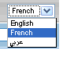  Figure 5 - select language box

Upon changing the language, all labels, messages, buttons and navigation elements will be displayed in the corresponding language if translated by the appointed portal administrators. Should these not be translated, they will appear in the default language – English.
The URLs for multilingual pages
If you wish to send the link to a certain page to someone and you want that person to read it directly in the language you choose, without having to manually choose the language and regardless of that person’s local settings or if you just want to publish multiple links to the same page in different translations, use the desired language code after the server name, preceded and followed by the slash “/” character.
Example:
Language version | URL
page URL: | http://www.example.com/asection/apage.html
explicit English version: | http://www.example.com/en/asection/apage.html
explicit French version: | http://www.example.com/fr/asection/apage.html
Table 3 - URL for multilingual page versions

Multilingual content
The SEMIDE portal is able to handle multilingual content, in the sense that each piece of information (news, events, files, documents, etc.) published in one language can be later translated in each of the languages available for the portal.
Moreover, files (PDFs, Word documents, etc.) can also have different versions for each language.
A default presentation language is set by administrators; so that when a text is not (yet) translated in one language, the translation in the default language of the website will be shown. This allows end users to know that a piece of information is published in the portal, even if it is not translated in their preferred language.

