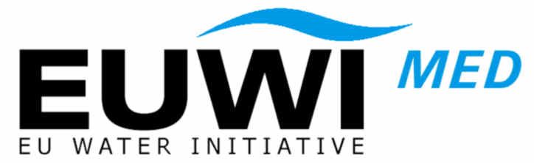  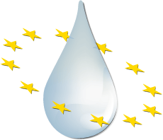 | MEDITERRANEAN EUWI/WFD JOINT PROCESS  “Work Programme 2007/2009”

Draft Mandate for a new activity on Waste Water Reuse

- Introduction

Further to the work undertaken by the drafting group on water scarcity and droughts and the MED-EUWI Working Group on Groundwater, the issue of waste water reuse was identified as a topic to be further addressed.

Indeed, during the discussion on Water scarcity and Droughts, where the issue of waste water reuse was identified as a way of addressing long term imbalances between supply and demand, no unique position was agreed on definitions, scope, sustainability and safety of waste water reuse. Final recommendations highlighted the need for further investigations and promotion of coordination and information exchange.

In the Med-EUWI Groundwater WG, the impact waste water reuse on the quality of groundwater was considered as a major issue to be addressed in a separate group. To this, it should be added the effects on soil functions, as described in the Commission's proposal for a Soil Framework Directive (COM(2006)232, 22.9.2006).

At the European level, there are no formal European definitions, nor guidelines addressing the issue of treated waste water reuse. Article 12(1) of the Urban waste water treatment directive (91/271/EEC) requires that "treated wastewater shall be reused whenever appropriate. Disposal routes shall minimise the adverse effects on the environment". The suitable guidelines and definition of "whenever appropriate" is needed to be defined at the EU level. This should, however, be seen in the light of the objectives of article 1 of the directive: "… to protect the environment from the adverse effects of waste water discharges".

Furthermore (referring to article 12(2) of UWWTD), it is important to notice that "the disposal of wastewater from urban wastewater treatment plants" also in terms for treated wastewater reuse, is subject to prior regulations and/or specific authorisation by competent authorities or appropriate bodies.

Therefore the exchange of experience already applied in the Member States regarding the implementation of article 12 of UWWTD are of major importance for developing EU-wide guidelines for treated wastewater reuse.

In the Mediterranean, these practises are of major importance. Waste water reuse is largely developed and could be expanded particularly in some countries. In water stressed areas, waste water reuse can contribute to alleviate the demand and in particular for irrigation.

In light of the above, it was proposed to include this topic as a theme for the second phase of the MED-EUW JP.
In addition, the issue will be linked to the Water Scarcity and Droughts activity under the CIS.

- Objectives and key subjects

The objective of this activity on waste water reuse is
- to assess the status of the situation with regards to treated waste water reuse in each of the EU Member States and non-EU countries participating in this activity,
- to get an overview of the issues at stake (definitions, scope, safety and sustainability) and
- to prepare the ground for potential more specific actions to be taken at the EU level.

This activity is targeted to the Member States, partner countries covered by the MED-EUWI, the Commission and interest groups.
It aims at facilitating exchange of experiences between experts (EU and non-EU) on this issue, to produce a common understanding of waste water reuse and to identify current practices in the EU and the Mediterranean.

Therefore, the objectives for this activity will be:

- Step 1: to collect information in the EU and non-EU countries on:
  - Waste water reuse definitions
  - Existing policies and strategies, legislation, standards, guidance documents, incentives…
  - Current practices, e.g. on treated waste water reuse and standards for treated wastewater to be re-used,
- Step 2: to assess, analyse and synthesize this information (thematic and geographical analysis)
- Step 3: to issue recommendations and draft follow-up actions

A preliminary scoping phase will be organised to identify
- key practical issues (i.e. (a) urban, domestic, industrial waste water; (b) when it is understood that wastewater is 'reused' and when it is 'disposed'; (c) receiving bodies, (d) safety issues),
- available materials developed by WHO, OECD, EUREAU and other European and international organisations, research projects, MS and interest groups (handbooks, manuals…), relevant adhoc experts, research institutions and targeted groups.

- Organisation

The activity will be led by Malta and the European Commission.
Membership includes MS, MEDA and Balkans countries representatives, experts from MEDA water and Research projects, and other experts.
Participation in this group is based on active contribution (drafting).

Aspects related to Groundwater will be coordinated with the Working Group C of the CIS dealing n particular with the Programme of Measures including exchanges on best available technologies.

- Expected outcomes and deliverables

The expected deliverables are:

- Report including the collected information and its assessment, synthesis, common understanding (definitions) of specific terms and recommendations for future actions
- Workshop summary report

- Contact person/s
Name | Organisation | E-mail
John Mangion | Malta | Chair
Sophie Breul-Busson | European Commission | Sophie.breul-busson@ec.europa.eu
Sylvie Detoc | European Commission | Sylvie.detoc@ec.europa.eu

- Timeframe

Inception meeting (scoping phase): March 2007
Second meeting June 2007
Final meeting December 2007
Presentation to Euro-Med Water Directors June 2008

Workshop: exchange of information: to be confirmed

